

LAB NO: (05)

NAME Aneel Kumar

ID BIT-23F-033

SECTION 3 (A)

SUBJECT Artificial Intelligence

TEACHER NAME Ma’am Aqsa

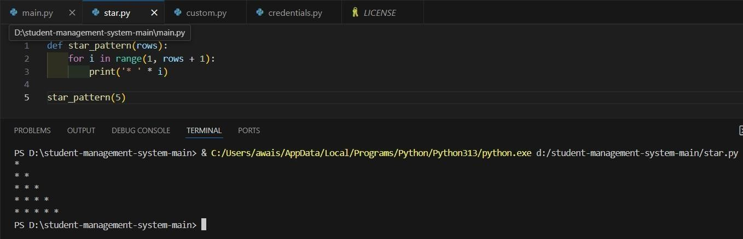

➢



Task One (Star Shape)



➢



Task Two (Print 1



-



10



Numbers



)



➢



Task Three (Print Even Numbers)

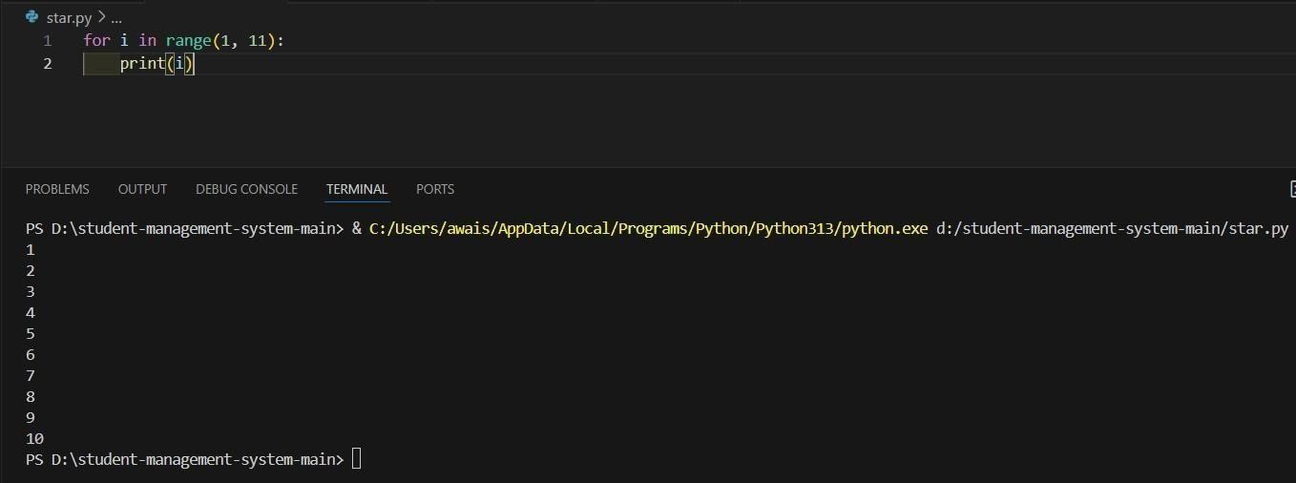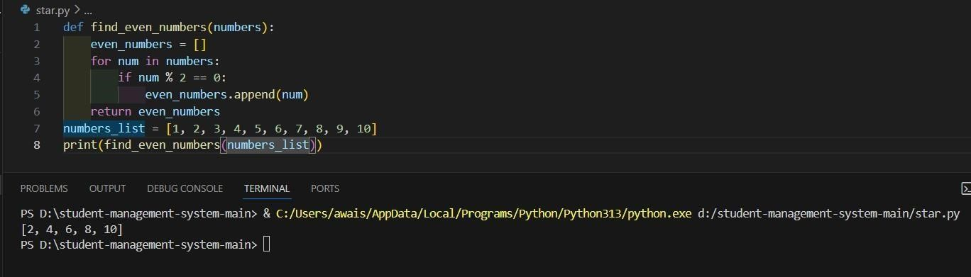

➢ Task Four (Sum of All Numbers)

